|  |
| --- |
| Style Guidelines |
| IT Department |

Document Control

This document is located within the [Company Name] SharePoint and is classified as Internal

****Revision History****

|  |  |  |  |  |
| --- | --- | --- | --- | --- |
| Date | Version | Status | Author | Summary of Changes |
|  |  |  |  |  |
|  |  |  |  |  |
|  |  |  |  |  |

Approvals Record

This document requires the following approvals

|  |  |  |  |
| --- | --- | --- | --- |
| Name | Title | Signature | Date |
|  |  |  |  |
|  |  |  |  |
|  |  |  |  |
|  |  |  |  |

Contents

1. Introduction 5

2. Legalities 5

3. Logos 5

3.1. Logo Use 5

4. Taglines 5

4.1. Tagline 1 5

4.2. Tagline 2 5

4.3. Tagline 3 6

5. Fonts 6

5.1. Aptos family 6

5.2. Work Sans 6

6. Colour Scheme 6

7. Style Sheets 7

8. Accessibility 8

8.1. Style sheets 8

8.2. Format 8

8.3. Language 8

8.4. General 8

8.5. Hyperlinks 9

8.6. Tables 9

8.7. Images 9

9. Available Templates 9

10. Saving Documents 9

11. Microsoft Applications 10

12. Style Guidelines 10

12.1. Accessibility Compliance 10

12.2. Bullet Points 11

12.3. Colons 11

12.4. Comma usage 12

12.5. Editor 12

12.6. General 12

12.7. Headings and Titles 12

12.8. Hyperlinks 12

12.9. Images 12

12.10. Names and Job Titles 13

12.11. Numbers 13

12.12. Spacing 13

12.13. Spelling 13

12.14. Tables 13

13. Visio 13

Introduction

The guide is meant to explain how [Company Name] expects it documents to be presented to ensure consistency, professionalism and our branding message is conveyed both internally and externally.

Legalities

* Under the Equality Act 2010, it is a legal requirement to make documents accessible.
* UK companies are legally required to display the registered address on all stationery and correspondence with clients. This includes invoices and letters.

Logos

The following logos can be used. The minimum size for the logo is x pixels wide x pixels high. This guide gives an overview of the key elements that affect most people in their everyday work; if you are in doubt, contact the IT Department.

The following colour combinations have been approved.

**Insert a diagram of approved logos**

Logo Use

* Don’t rotate the logo
* Don’t recolour elements
* Don’t alter the logo’s proportions
* Don’t alter the relationship between the elements
* Don’t alter the typeface
* Don’t use on coloured backgrounds
* Don’t use visual effects (e.g. drop shadow)
* Don’t outline the logo
* Don’t enclose the logo in a holding shape
* Don’t add text to the logotype
* Don’t use the symbol on its own
* Don’t use the logotype on its own

Taglines

These taglines can be used in the following formats. They are displayed as full width banners.

Tagline 1

Image for tagline 1 and description of where used.

Tagline 2

Image of tagline 2 and description of where used.

Tagline 3

Image of tagline 3 and description of where used.

Fonts

There are two font families available for use:

* Aptos
* Work Sans

Aptos family

The Aptos family of fonts should be used for all everyday needs such as documentation produced in Word, Excel, PowerPoint, Outlook, Visio, and Project whether internal or external facing.

|  |  |  |
| --- | --- | --- |
| Font | Size | Use |
| Aptos Light | 14 | Title/Heading |
| Aptos Semi-Bold | 12 | Subtitle / Sub Heading |
| Aptos Regular | 11 | Body of document |

Work Sans

This family of fonts should be used for all other communication such as marketing materials, websites, and posters.

|  |  |
| --- | --- |
| Font | Size |
| Work Sans Light | 52 |
| Work Sans Medium | 32 |
| Work Sans Regular | 24 |

Colour Scheme

The [Company Name] colour scheme is as follows:

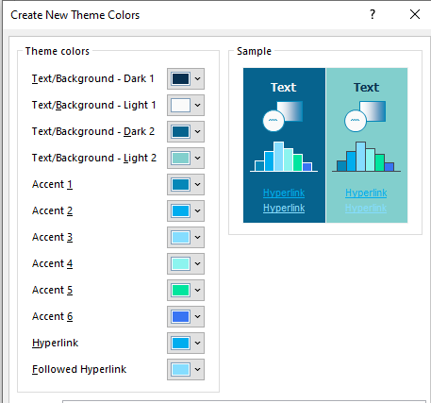

The RGB and Hex codes for the colours are as follows:

|  |  |  |
| --- | --- | --- |
| Theme Colour | RGB | Hex |
| Text/Background – Dark 1 | 8, 48, 80 | #083050 |
| Text/Background – Light 1 | 250, 250, 250 | #FAFAFA |
| Text/Background – Dark 2 | 6, 99, 142 | #06638E |
| Text/Background – Dark 2 | 130, 207, 205 | #82CFCD |
| Accent 1 | 5, 135, 184 | #0587B8 |
| Accent 2 | 0, 173, 239 | #00ADEF |
| Accent 3 | 133, 221, 255 | #85DDFF |
| Accent 4 | 140, 244, 239 | #8CF4EF |
| Accent 5 | 0, 229,158 | #00E59E |
| Accent 6 | 56, 116, 243 | #3874F3 |
| Hyperlink | 0, 173, 239 | #00ADEF |
| Followed Hyperlink | 133, 221, 255 | #85DDFF |

Style Sheets

The style sheets in Microsoft Word must be used to format documents to ensure consistency in the layout and styling of all documentation leaving [Company Name]. A range of styles have been embedded into each template and are incorporated into user profiles.

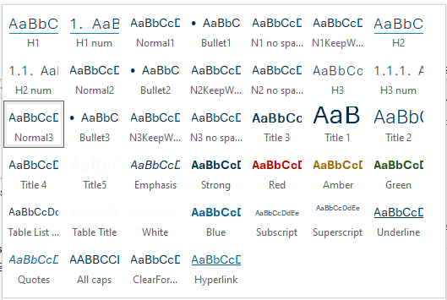

Styles should be used as they:

* Help to ensure documents remain accessible to all users
* Provide consistency across all documentation.

Accessibility

Under the Equality Act 2010, it is a legal requirement to make documents accessible. The [government website](https://www.gov.uk/guidance/publishing-accessible-documents) includes guidance on publishing accessible documents.

Style sheets

Style sheets have been created to ensure consistency of document output from [Company Name] and also to help ensure that documents are accessible. Formatting should be applied from the style sheets as screen readers can recognise these to emphasis headings, bold, tables etc.

Format

PDFs do not work well with screen readers, so it is best to avoid. It is much better to publish in html format or keep in the original Word, Excel format.

Language

Keep the language simple and use clear concise sentences. Always spell out abbreviations, acronyms, technical terms on first use and if a lot of terms are used include a glossary of terms as a useful reference.

General

* All documents should have a meaningful title.
* Use short sentences (25 words or less) on average.
* Use a sans serif font. Aptos and Work Sans fonts are both sans serif fonts.
* Do not use justified font
* Avoid columns
* Avoid underlining, except for links.

Hyperlinks

* Hyperlinks should be clearly labelled with where they are going. For instance, do not use Click Here, instead include within the context of the sentence as shown in the following sentence. Visit this [government website](https://www.gov.uk/guidance/publishing-accessible-documents) to see further guidance on publishing accessible documents.

Tables

* **Do not merge or split cells.**
* **Every table should have a heading.**
* **Use the styles on the style sheets for formatting tables.**

**Images**

* Use alt text for all images.
* When using alt text, think how a screen reader would read out the text. Acronyms need to be typed with a space otherwise they will be read as a word, N H S not NHS, but NASA not N A S A.
* Use full stops at the end of sentences.
* Avoid text in images unless you have also explained in the body of the document.

Available Templates

Templates are stored in each user profile and can be accessed in the following way.

* Open the relevant Office Product
* Select File > New > Personal
* Select the required template.

Saving Documents

When saving documents, the document should be saved with a name that describes the document. Versioning MUST NOT be applied to any document names once they are uploaded onto the company SharePoint. This creates multiple versions of the document, and it is difficult to track the development, and therefore changes to a document.

To check the history of a document and to see the changes that different people have made:

1. In Sharepoint, locate the document.
2. Right click on the ellipsis alongside the document name.
3. Select Version history.
4. You can then see who has made changes to a document and when
5. Select the date to open a specific version of that document.

Microsoft Applications

The default font and [Company Name] colour scheme is embedded into each user profiles. The [Company Name] Colour Scheme should always be used. Aptos Display should be used within Project and Visio.

Style Guidelines

The following guidelines should be followed for documentation.

Accessibility Compliance

* Always run the accessibility checker and correct any problems found. The bottom of the screen constantly gives the status of the document.

Screenshot showing the accessibility checker icon at the bottom of the screen, 

* You can run accessibility by selecting File > Info > Check for Issues > Accessibility Checker.
* **Remember it is a legal requirement to make documents accessible.**

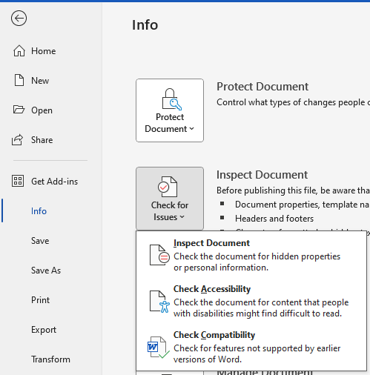

Bullet Points

* All bullet points should start with a capital. If it is a series of short bullet points, then one full stop at the end can be used.
* If the bullet points are sentences, then full stops should be used at the end of each bullet point.
* A sentence leading into a list of bullets should be followed by a colon.
* Numbered bullet points should only be used when an order must be followed. They should start with capitals and finish with a full stop as each is an individual instruction.

***Examples***

*The centre offers three sports:*

* *Tennis*
* *Badminton*
* *Squash.*

Colons

Use a colon to introduce a short list or to introduce a topic.

**Examples:**

*I have found the best route to London; it is via the M3.*

*The centre offers three sports: tennis, badminton, and squash.*

*The centre offers three sports:*

* *Tennis*
* *Badminton*
* *Squash.*

Comma usage

The Oxford comma should be used to avoid confusion. Generally speaking, the Oxford comma is used before ‘and’.

***Example 1 – To thank 2 people, the parents who are called Mr Smith and Mrs Jones.***

*I thanked my parents, Mr Smith and Mrs Jones.*

***Example 2 – To thank 4 people; the parents and two other people.***

*I thanked my parents, Mr Smith, and Mrs Jones.*

Editor

* Use the Editor icon on the Home Tab to check your work. The setting should be set as professional.

General

* One space after a full stop.
* Where one is available a recognised template should be used. If you need a template created, please contact the Quality and Compliance Officer.
* Avoid columns because it reduces accessibility.
* Avoid justification because it reduces accessibility.
* The oxford comma should be used as it improves readability.

Headings and Titles

These are built into the style sheets and should be used. Each Heading indents in by one cm. The corresponding bullet points and text should be used to ensure consistency of layout.

Example

H1

Normal1

Bullet1

H2

Normal 2

Bullet 2

Hyperlinks

* Always incorporate into the sentence so they explain the context of the link.

Images

* Add alt text to every image.
* If an image is purely decorative and does not add to the document, you can mark as decorative, so screen readers ignore it. There will be very few occasions where this is used.
* Do not mark all images as decorative as this could put [Company Name] in breach of accessibility guidelines.

Names and Job Titles

Use Title Case for people’s names and job titles.

***Examples***

*Fred Smith, President, asked that all managing directors report to his office.*

Numbers

When using numbers in a document, any number lower and including ten should be written out and numbers higher than ten should be typed as numbers, except when typing numbers into a table when the numeric form should be used.

Spacing

Use one space at the end of each sentence following a full stop.

Spelling

Always use British English.

Always use the Editor tool to highlight any problems, bearing in mind that it does not pick up everything and is not always right.

Tables

* Always use headers.
* Avoid empty cells; some screen readers will stop at this point and ignore the rest of the information in the table.
* Do not merge or split cells.
* Avoid fixed width tables as they will not resize on different devices.

Visio

To get the correct colour scheme in Visio you need to manually set it up:

* Open Visio.
* Select the Design Tab.
* Select Theme > Variants will become active.
* Click on Drop Down arrow > Select Colours.
* Select Create New Theme Colours.
* Add in the 9 different theme colours > Name as [Company Name].
* You can then create your Visio Drawing.
* Select Variants and ensure that the [Company Name] colour scheme is selected.
* Select Effects and select Organic.
* Select Themes and ensure that the custom theme is selected.

Unfortunately, Visio does not carry forward theme so do the following to save having to recreate the theme for your next drawing

* Select File > New.
* Copy and paste a formatted shape from a previous drawing.
* Go to themes and select Office.
* Go to Variants > Colours > Select [Company Name] Colour scheme.
* Go to Variants > Effects > Select Organic.